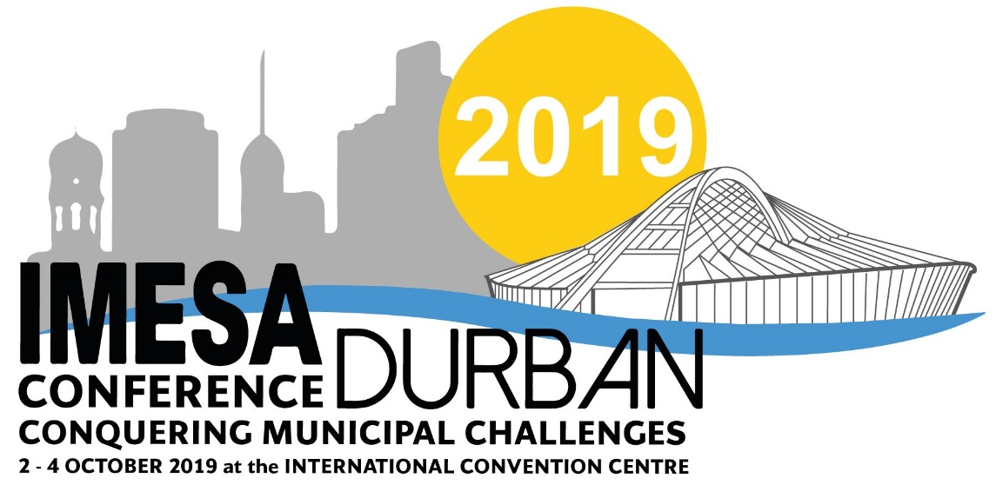

C A L L F O R A B S T R A C TS

C O N F E R E N C E T H E M E F O R 2 0 1 9
“Conquering Municipal Challenges”

With all the challenges facing our industry today, economic, social, environmental or political, we need to adapt and be original. This starts with the local authorities, where most of us perform some function to serve our communities.

Abstracts typically falling within the following broad areas are encouraged for submission:

- Buildings, Structures and Housing
- Ecological, Environmental and Social
- Electrical and Electronic
- Financial, Legal and Regulatory
- Transport, Roads and Stormwater
- Water and Sanitation

The title and topic will be evaluated for innovation, thought, leadership, business value and interest and conformance to the Conference theme. Only the best will be selected to go to the next phase.

THE PROCESS
Participants are required to go through a review process called the Call for Papers process. All stages of the process is reviewed by a Technical Advisory Committee. The process has 3 Phases:-

PHASE 1  SUBMISSION - ABSTRACT | PHASE 2  SUBMISSION - FULL PAPER | PHASE 3  SUBMISSION - PRESENTATION
Deadline - 26 February 2019  AFTER REVIEW –  Participants will be notified if they will be moving to Phase 2. | Deadline - 24 May 2019  Deadline applicable ONLY to successful participants of Phase 1.  AFTER REVIEW –  Participants will be notified if they will be moving to PHASE 3. | Deadline - 19 August 2019  Deadline applicable ONLY to successful participants of Phase 2.  Participants completing this Phase will be Presenting at Conference

To submit an ABSTRACT FOR CONSIDERATION, fully complete the ABSTRACT SUBMISSION FORM in English in word format.

Completed submissions to be forwarded to:
Melanie Stemmer at marketing@imesa.org.za
Tel: 031 266 3263
ABSTRACT SUBMISSION FORM
INSERT
PHOTO
HERE
2019 IMESA CONFERENCE
Durban International Convention Centre (ICC)
02 – 04 October 2019
www.imesa.org.za
031 266 3263

NAME(S) & SURNAME:
ORGANISATION:
CONTACT DETAILS: | TELEPHONE: |  |  |  | CELL:
 | EMAIL:
SPEAKER RESUME - 200 words maximum
* NOTE: Key points to include are the following:
Qualifications / Current position and past experience / Any seats held on various engineering boards
Any research you might have done / Any relevant additional information
ADDITIONAL PRESENTER - Complete ONLY if there will be an ADDITIONAL PRESENTER
NAME(S) & SURNAME:
ORGANISATION:
CONTACT DETAILS: | CELL: |  |  | EMAIL:
PRESENTERS PROFILE:

DETAILS OF SUBMISSION
CATEGORY OF SUBMISSION: |  | Buildings, Structures and Housing
 |  | Ecological, Environmental and Social
 |  | Electrical and Electronic
 |  | Financial, Legal and Regulatory
 |  | Transport, Roads and Stormwater
 |  | Water and Sanitation
TITLE OF PROPOSED PRESENTATION:
ABSTRACT - 350 to 400 words
* NOTE: Take caution of word count as you could be marked down should you exceed required word limit
KEY PRESENTATION IMPACT POINTS:
OUTLINE OF PRESENTATION:

Completed submissions IN WORD FORMAT to be forwarded to Melanie Stemmer on marketing@imesa.org.za

